**Aim**

To design and implement an Industrial Safety and Security System using Arduino Uno, GSM 900A Module, DHT 11 Sensor, IR Sensor, Flame Sensor, MQ2 Sensor, a relay, and an exhaust fan, which ensures safety by detecting harmful conditions and notifying the concerned authorities.

**Abstract**

The Industrial Safety and Security System is an automated solution aimed at monitoring and mitigating hazardous conditions in industrial environments. The system uses various sensors to detect temperature, humidity, smoke, gas leaks, infrared intrusions, and flames. Upon detecting any abnormal condition, the system activates an exhaust fan to reduce hazards and sends alert messages to the concerned personnel using the GSM 900A Module. This project enhances safety measures and ensures prompt responses to potential threats.

**Components Required**

1. Arduino Uno
2. GSM 900A Module
3. DHT11 Sensor
4. IR Sensor
5. Flame Sensor
6. MQ2 Sensor
7. Relay
8. Exhaust Fan
9. Connecting Wires
10. Power Supply

**Components Explanation**

**Arduino Uno**

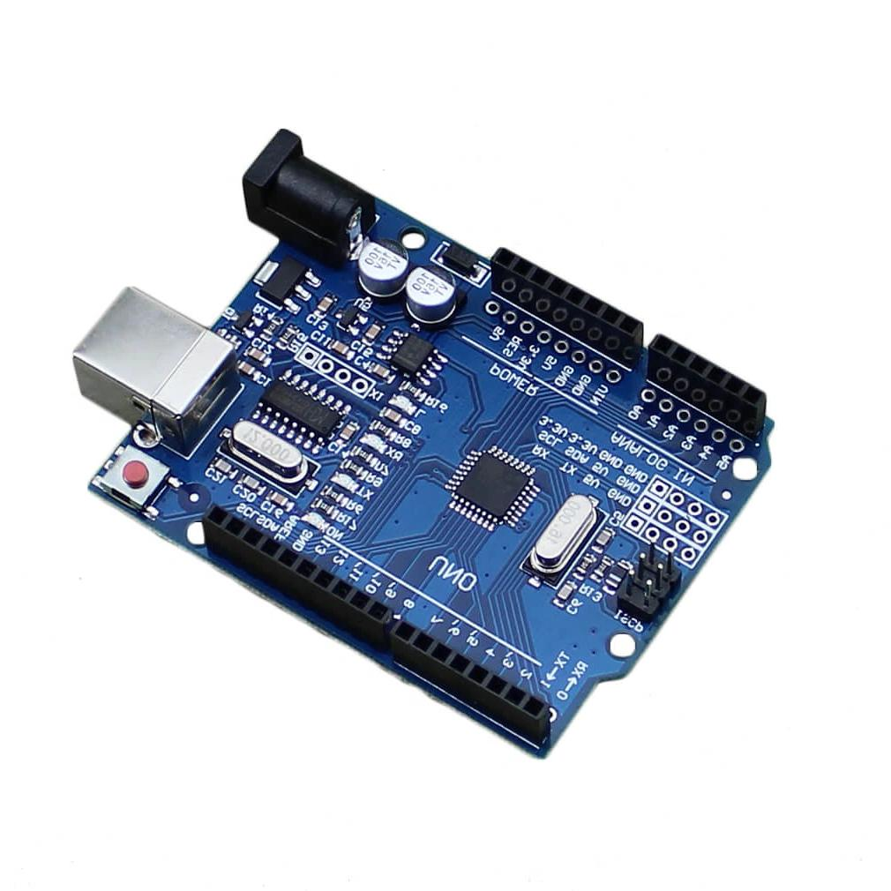

* **Description**: An open-source microcontroller board based on the ATmega328P, featuring digital and analog input/output pins, a USB connection, a power jack, and a reset button.
* **Function**: Acts as the central control unit that processes inputs from sensors and controls outputs like the relay and GSM module.

**GSM 900A Module**

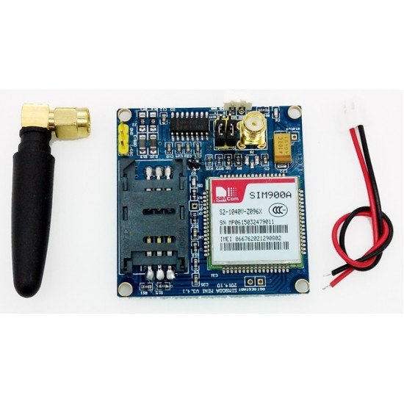

* **Description**: A GSM module that enables communication via SMS.
* **Function**: Sends alert messages to predefined phone numbers when any sensor detects a hazardous condition.

**DHT11 Sensor**

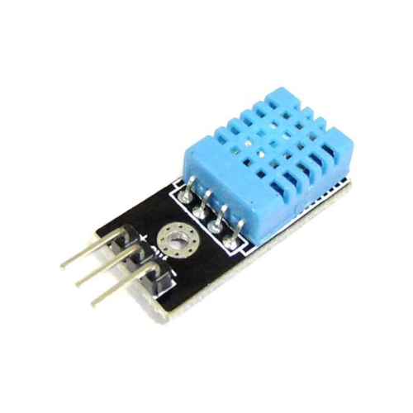

* **Description**: A sensor that measures temperature and humidity.
* **Function**: Monitors environmental conditions to detect abnormal temperature and humidity levels.

**IR Sensor**

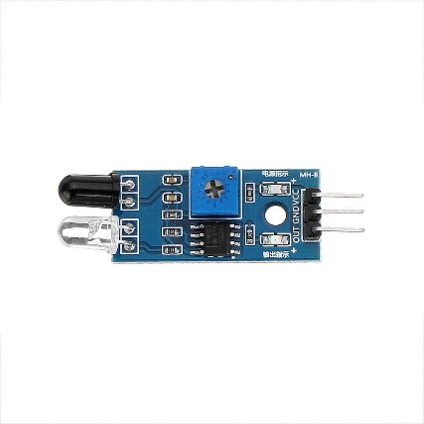

* **Description**: An infrared sensor that detects obstacles and motion.
* **Function**: Used to detect unauthorized entry or presence within the monitored area.

**Flame Sensor**

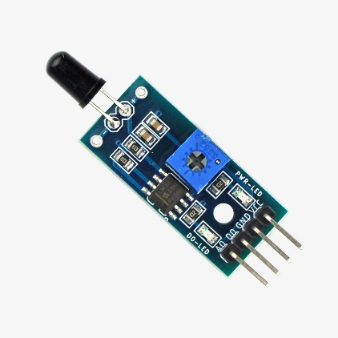

* **Description**: A sensor that detects the presence of flame or fire.
* **Function**: Alerts the system in case of fire, triggering safety protocols like activating the exhaust fan.

**MQ2 Sensor**

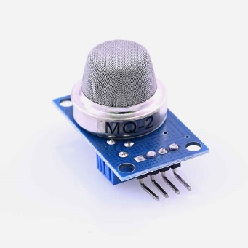

* **Description**: A gas sensor capable of detecting smoke and combustible gases.
* **Function**: Monitors air quality to detect harmful gases and smoke, initiating necessary actions if dangerous levels are detected.

**Relay**

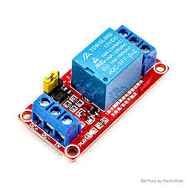

* **Description**: An electromechanical switch used to control a high-power device with a low-power signal from the Arduino.
* **Function**: Controls the exhaust fan based on signals from the Arduino.

**Exhaust Fan**

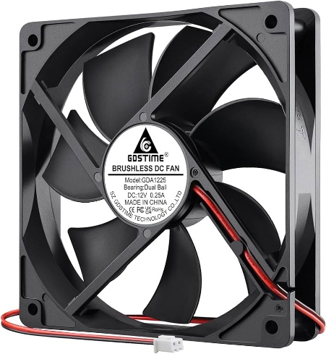

* **Description**: A fan used to ventilate and reduce hazardous fumes and gases.
* **Function**: Activated to clear smoke or gas from the environment when detected by the MQ2 sensor.

**Working Procedure**

1. **Initialization**: Power up the system, initializing all sensors and modules.
2. **Monitoring**: Sensors continuously monitor the environment for temperature, humidity, smoke, gas, fire, and unauthorized movement.
3. **Detection**: Upon detecting any abnormal condition (e.g., high temperature, smoke, gas leakage, flame, or unauthorized entry), the corresponding sensor sends a signal to the Arduino.
4. **Response**:
   * **GSM Alert**: Arduino activates the GSM 900A module to send an alert message to the predefined phone number.
   * **Activate Fan**: Arduino triggers the relay to turn on the exhaust fan to ventilate the area if smoke or gas is detected.
5. **Continuous Monitoring**: The system continues to monitor and respond to conditions in real-time, ensuring ongoing safety.

**Advantages**

* **Real-time Monitoring**: Continuous surveillance of environmental conditions.
* **Prompt Alerts**: Immediate notification via SMS in case of hazardous conditions.
* **Automated Response**: Automatic activation of exhaust fan to mitigate risks.
* **Versatility**: Can be adapted to various industrial safety requirements.
* **Cost-effective**: Uses readily available and affordable components.

**Disadvantages**

* **Limited Range**: GSM module requires a mobile network for sending alerts.
* **Maintenance**: Requires regular maintenance of sensors for accurate readings.
* **Dependency on Power Supply**: Needs a reliable power source for continuous operation.

**Conclusion**

The Industrial Safety and Security System provides an effective and efficient solution for monitoring and ensuring safety in industrial environments. By integrating various sensors and automation, the system can detect and respond to potential hazards promptly, thus preventing accidents and enhancing overall safet